23.17: a) Work done is zero since the motion is along an equipotential, perpendicular to the electric field.
b) 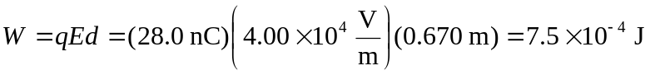
c) 